**Vivado software setup guide**

**Step 1: Click on Xilinx setup – “xsetup” available in the folder of the software proivded. Follow the instruction as below.**

**The installation takes one and half hour have patience**

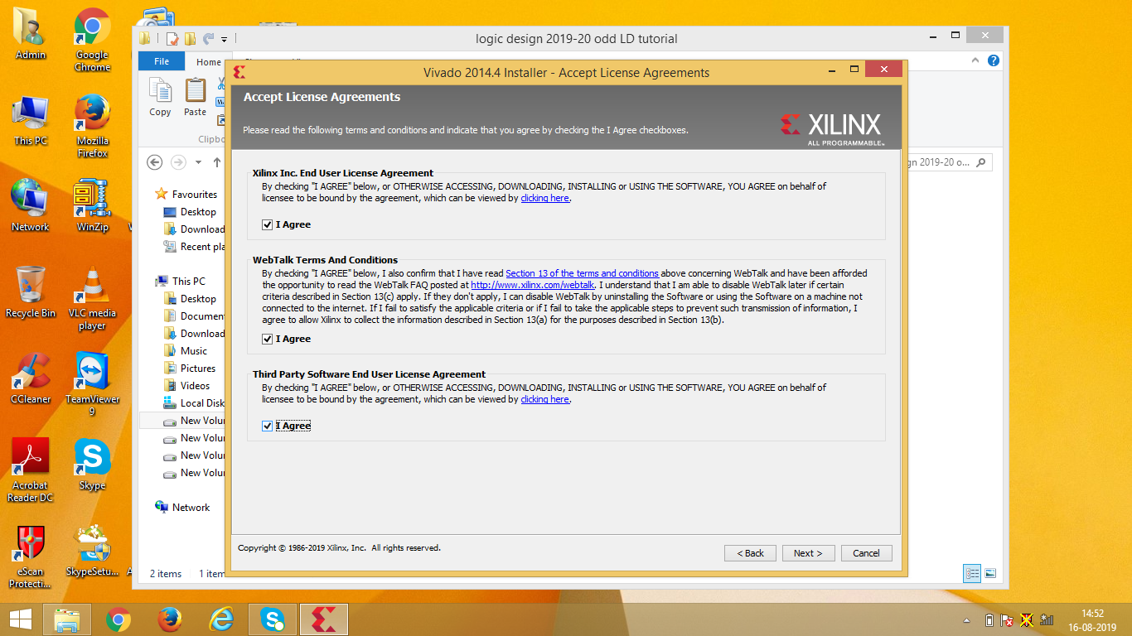

**Fig 1: Licence**

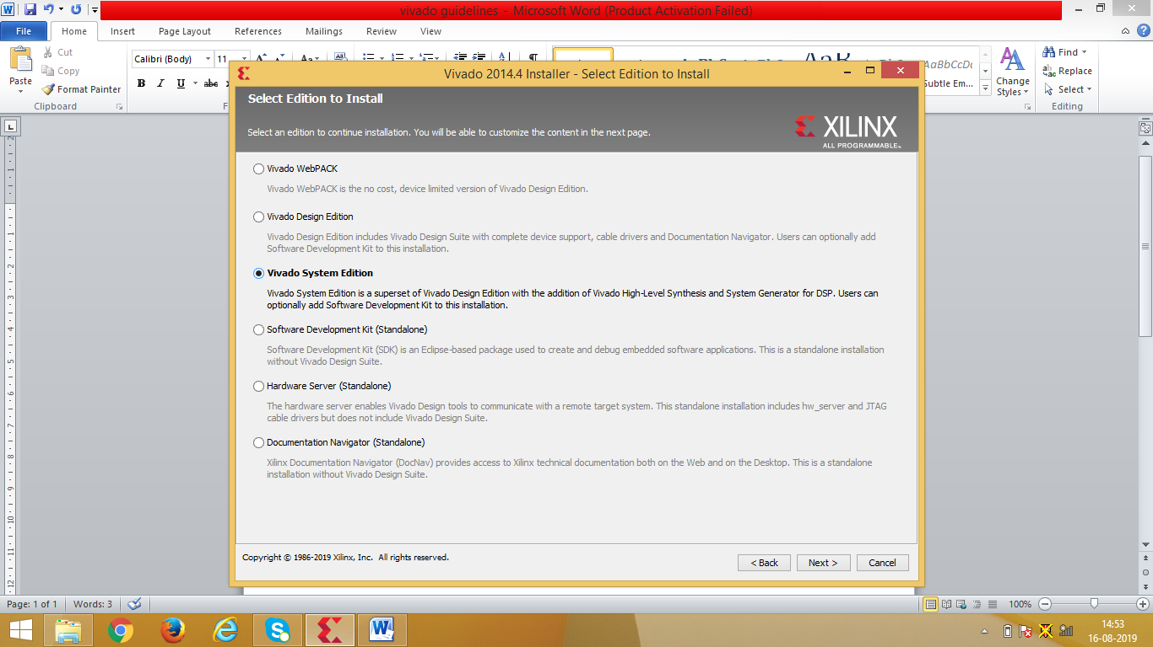

**Fig 2: System edition**

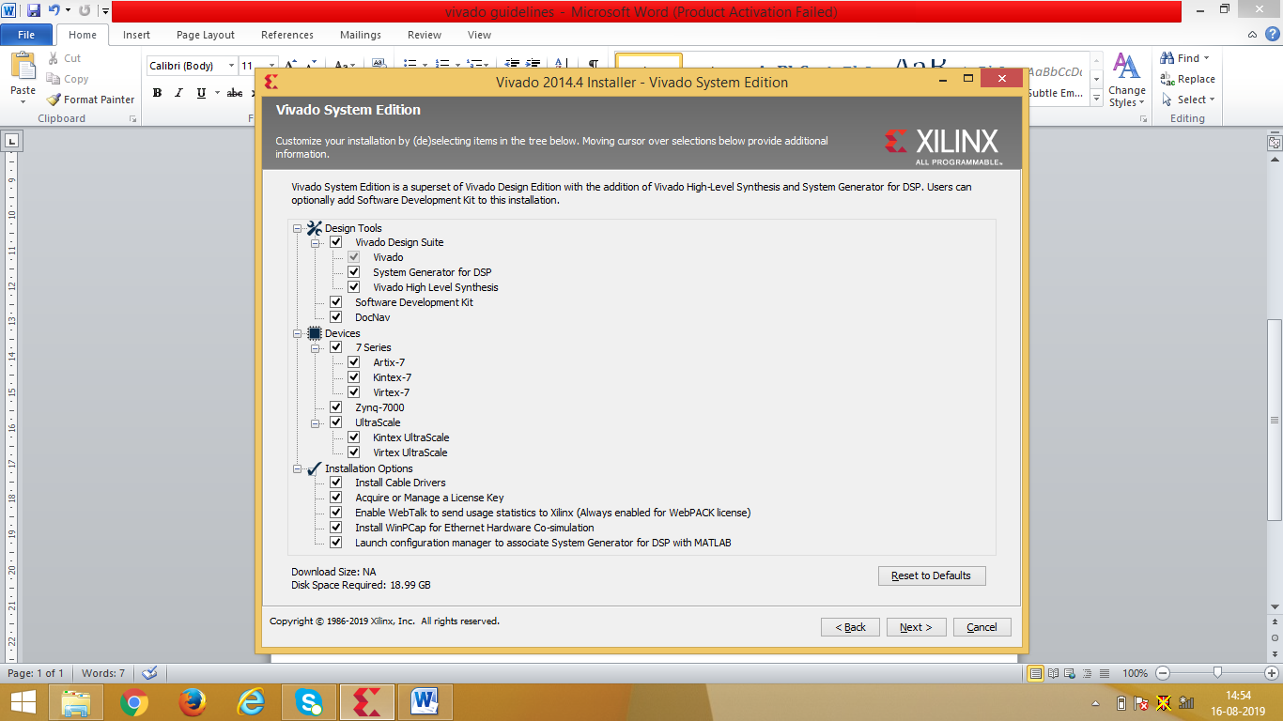

**Fig 3: System edition setting**

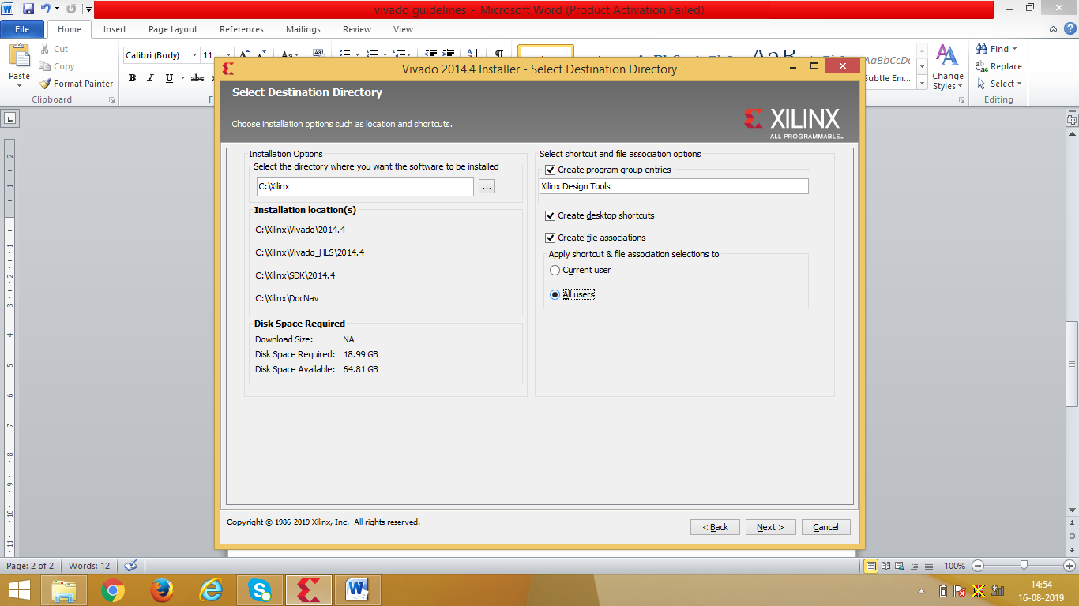

**Fig 4: Select all users**

Next till installation, everything else is default

1. Say yes to Jungo LTD and Xilinx installations
2. Now click on Load licence on Left side of the panel. Here click on copy licience and select the files one by one which is available in XILINX lic. You can view the liceince status and get to know whether it is permanent. If yes, it means that licence of the software is done.

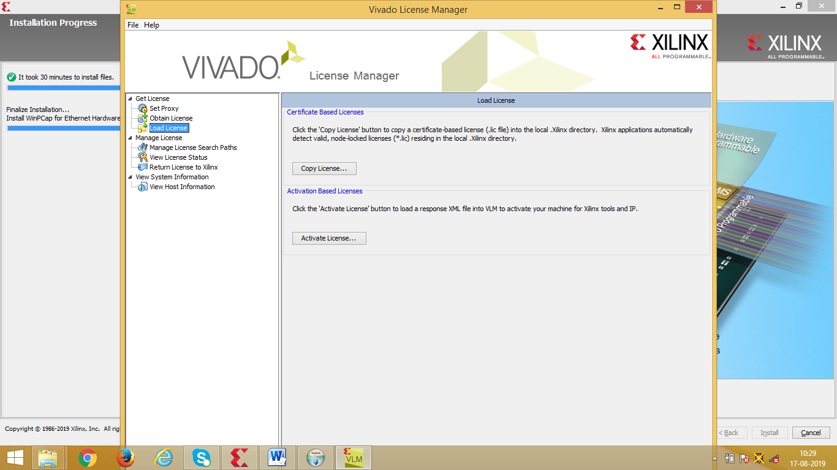

**Fig 5: Load Licence**

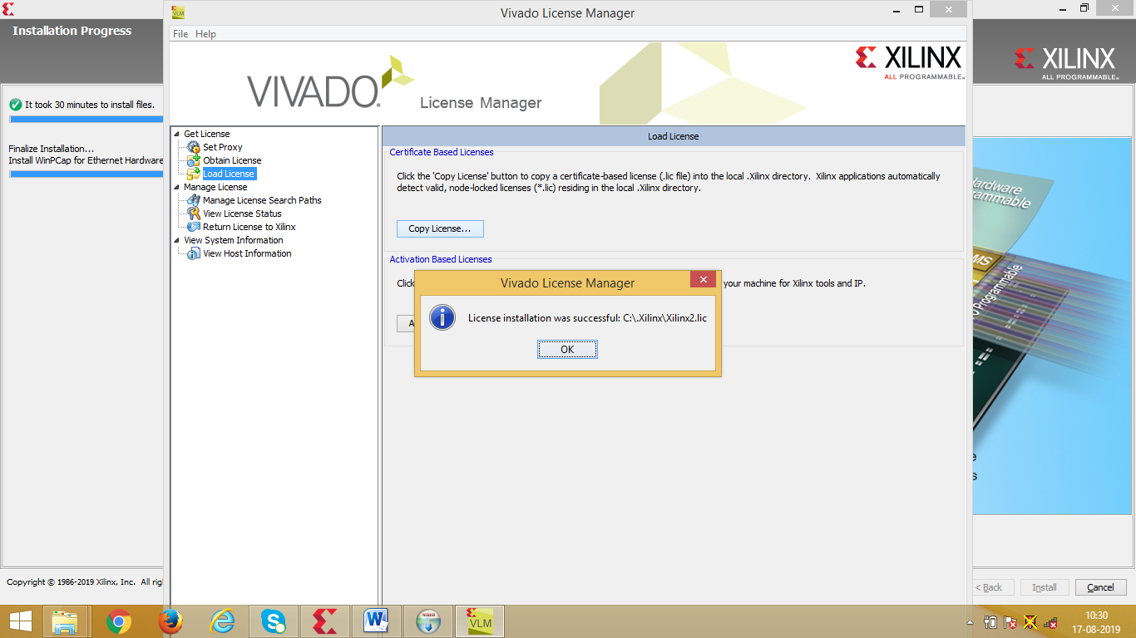

**Fig 6: successful installation of licence once browsed**

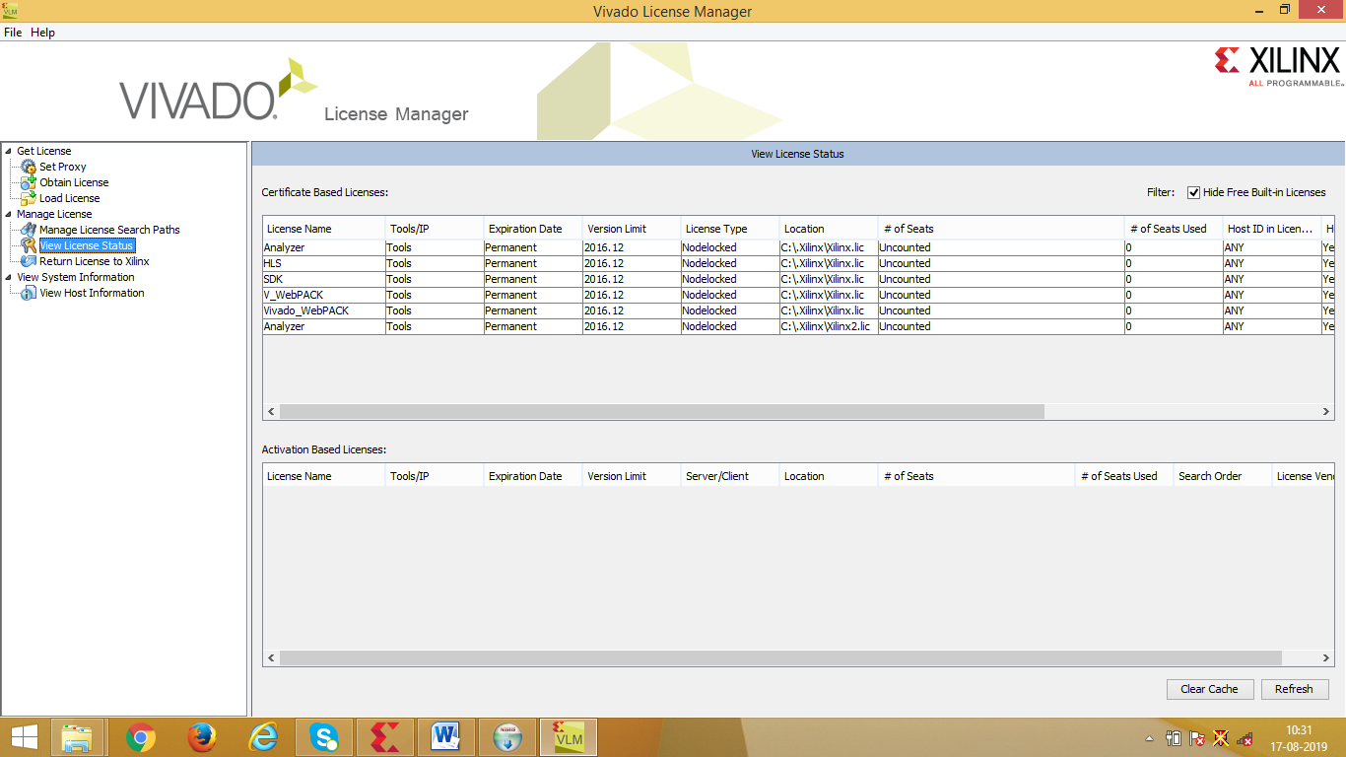

**Fig 7. View licence status – left panel after successful installation of the two copies**

In “Xilinx Lic” folder there are two files available. copy it to the following as shown:

Install Wincap s it is required

MAtlab simply say ok

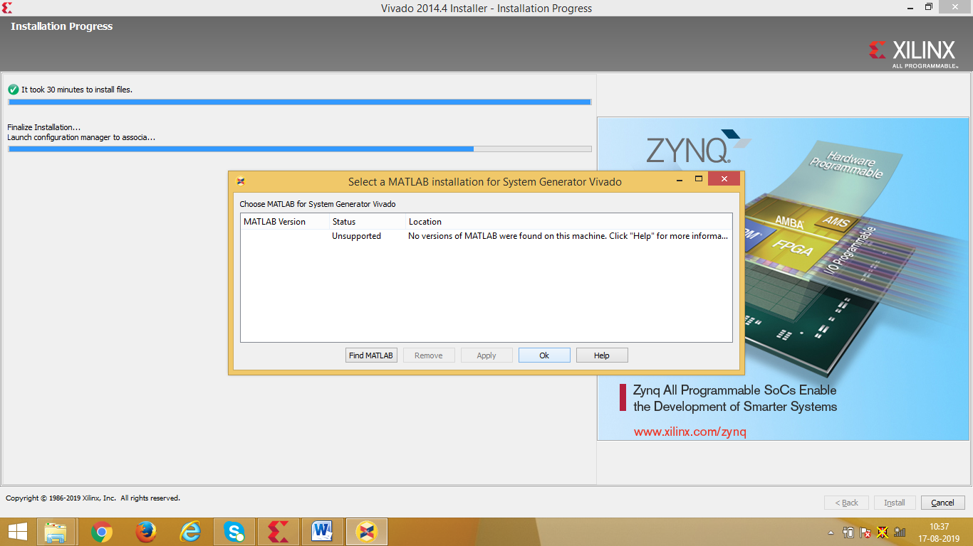

**Fig 9. MAtlab no required**

After ok installation will complete

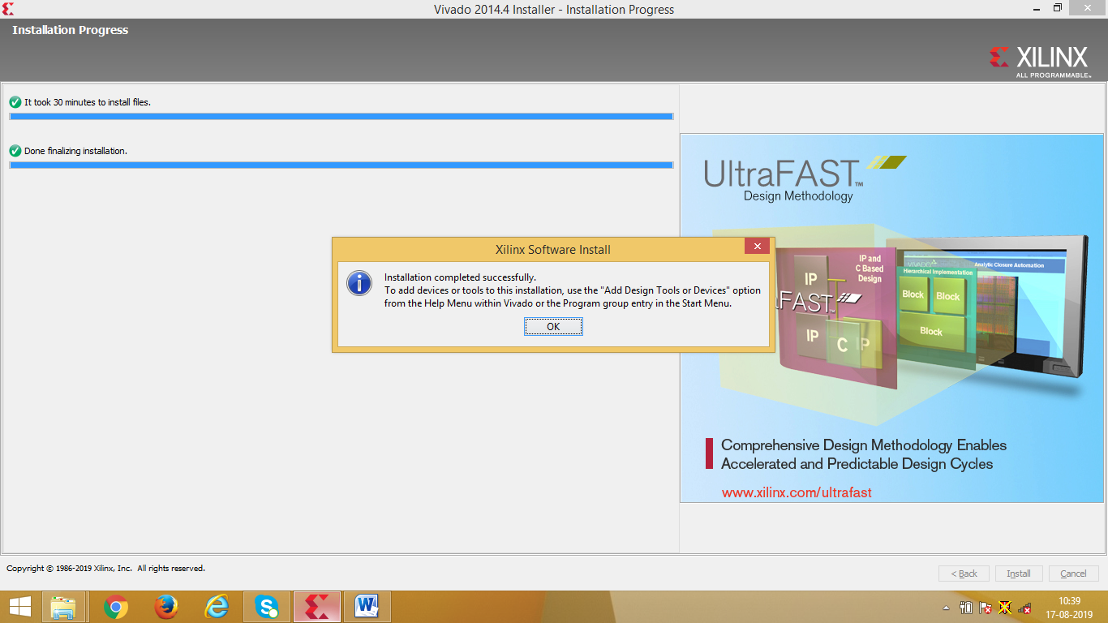

**Fig 10. Installation successful**

Click on Vivado 2014.4 icon available on the desktop. There are other two icon which you can ignore